Date: | June 2023 | 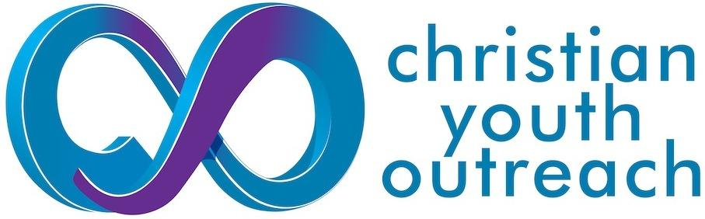  Data Privacy and Security Notice | Document number: | CYO6
Version: | 4 |  | Author: | Angela  Morley
Review Date: | June 2024 |  | Reviewed by: | Sam Fowler

Who Are We?
North East Essex Christian Youth Outreach (CYO) works with young people in schools and colleges across the Colchester area to support them in their wellbeing and to offer opportunities to explore spirituality and faith. For more details about our history and background please visit our website: www.cyocolchester.org.uk We value everyone who engages with us by whatever means and we do all that we can to make sure your personal data is kept safe.
We are a UK registered Charitable Incorporated Organisation, No. 1168047
This Data Privacy and Security Notice is designed to comply with the DPA (Data Protection Act 2018) and UK General Data Protection Regulation (UK GDPR) and is issued in the interests of transparency over how we use (“Process”) the Personal Data we collect.

Your Personal Data – What is it?
Personal data relates to a living individual who can be identified from that data. Identification can be by the information alone or in conjunction with any other information in the data controller’s possession or likely to come into such possession. The processing of personal data is governed by the UK General Data Protection Regulation (the “UK GDPR”).

What do we do with Your Personal Data?
CYO will only collect and retain data that is required in connection with the relationship you have with us (for example, donor, supporter, partner organisation, someone with an interest in our work, employees). We will provide you with information that we believe is important, in your interest to know, or that you have permitted us to send to you.

We may use the information you provide to:
- tell you about our work, news, provide information on our resources or forthcoming events
- ask you for financial and non-financial support, such as volunteering or prayer.
- let you know about other projects or events that may be of interest to you and are consistent with our charitable purposes.
- to review the use which visitors make of our website, to respond to your communications with us or questions, and to protect website security.
- to manage our employees and volunteers.
- to maintain our accounts and records (including the processing of gift aid applications).

We will not:
- sell or rent your information to third parties.
- share your information with third parties for marketing purposes.

What is the Legal Basis for Processing your Personal Data?

Legitimate interest:
We may hold your data where we have a legitimate interest to do so. For example: if you sign up to attend an event, or be part of a program or prayer space, we will need to keep your data in order to inform you of the relevant details and to allow us to respond to possible safeguarding queries.

Consent:
We may also hold your data and contact you by post, telephone, email or text if you have given us your consent to do so. We will only communicate in accordance with your preferences and you are free to change your preferences at any time by contacting us by telephone, post or email as shown in the section ‘Your rights and telling us when things change’ below.

Applying for a job or volunteering with us:
If you apply for a job or volunteer role with us, we will store data you provide to us. The lawful basis under which we do this is “Performance of Contract”. Where you provide personal data and sensitive personal data when applying for a job or volunteering opportunity with us, we will process, store and disclose the data we collect in order to:
- Answer any questions you may have.
- Support the administration of the employment or volunteer role.
- Support the recruitment process

Financial donors:
We will hold data about you under the lawful basis of “Performance of Contract”, because you give us ﬁnancial support and we undertake to use the money for the purpose for which it was given. We also have to be able to demonstrate the source of our donations to the Charities Commission, and to justify Gift Aid claims to HMRC.

When we Share Your Information
Your personal data will be treated as strictly confidential. We may pass your information to our third party service providers, agents, subcontractors and other associated organisations for the purposes of completing tasks and providing services to you on our behalf (for example to process donations and send you mailings). However, when we use third party service providers (like, but not limited to, the ones mentioned earlier) we disclose only the personal information that is necessary to deliver the service and they in turn are bound by UK GDPR to keep your information secure and not to use it for their own direct marketing purposes.
We may need to pass on information if required by law or by a regulatory body. For example, a Gift Aid audit by the HMRC, or if asked for details by a law enforcement agency.

Personal Data Collected on Our Website
We do not obtain any personally identifiable information about you when you just view our website. We do collect non-personal data via Google Analytics:
- Google Analytics is a web analytics service that uses cookies stored on your computer to collect and report website usage data. We use Google Analytics to help us learn more about how visitors are interacting with our web site. Google collects the IP address you use when you visit the site but does not collect any other personal information about you. We do not combine the information that Google collects with any other personally identifiable information. You can read more about Google Analytics data privacy and security on https://www.google.com/analytics/terms/us.html

If you provide us with any personal information about you whilst using our website, we may use it to inform you and any services or information that you have requested by using Mailchimp and Stewardship:
- Mailchimp: When you sign up to receive our email newsletters the information you provide is collected by Mailchimp on our behalf and is shared with us but with no one else. You can read more about Mailchimp’s legal and privacy policy
https://mailchimp.com/legal/privacy/

- Stewardship: When you make a donation to CYO through the giving link on our website the information you provide is collected by Stewardship and is shared with us but with no one else. You can read more about Stewardship’s Privacy Policy at
https://www.stewardship.org.uk/transparency/privacy

The privacy policies of any other websites which you access through links from our website are not controlled by CYO or subject to our Data Privacy and Security Notice. We suggest you check the third party website for more information about their cookies and how to manage them.

How Long do we Keep Your Personal Data?
We will hold your information only for as long as is necessary and we review our retention periods for personal information on a regular basis. We are legally required to hold some types of information to fulfil our statutory obligations (for example the collection of Gift Aid).

How Safe is Your Data?
We ensure that access to personal data is restricted only to those staff members or volunteers whose job roles require such access and that suitable training is provided for these staff members and volunteers.

Where Do We Store Your Data?
Any physical records are kept in a secure, locked ﬁling cabinet at the CYO ofﬁce. The key is only available to authorised members of staff. Electronic records are held in a secure database, which requires a login and password and is held on a secure server. Only authorised team members of CYO have access to the database. When an authorised team member leaves, their account is disabled.

Your Rights and Your Personal Data
It is important to us that the information we hold is accurate, up to date, and that we are using it in the way that you expect. We fully recognise your right to have your data removed once we no longer have a lawful basis to keep it. You can change your preferences about what you receive from us at any time. You also have the right to lodge a complaint with the Information Commissioner’s Office at https://ico.org.uk

Please contact us if you would like to:
- review the information about you that we hold (to ensure the confidentiality of everyone’s data, in some circumstances we may need proof of identity before we can release this information).
- update your information, for example your email or postal address
- ask us to delete all of the information about you that we hold.

Further Processing
If we wish to use your personal data for a new purpose, not covered by this Data Protection Notice, then we will provide you with a new notice explaining this new use prior to commencing the processing and setting out the relevant purposes and processing conditions. Where and whenever necessary, we will seek your prior consent to the new processing.

Contact Details

You can contact us by:
- email: mail@cyocolchester.org.uk
- our registered address: CYO Colchester, c/o Kingsland Church, 86 London Road, Colchester, CO3 9DW

Review Record
Date of Review: | Reviewed by: | Comments:
May 2020 | Stef Jones | Approved by Time Abbott CEO 21.5.20
May 2021 | Stef Jones
November 2021 | Stef Jones | Changed all references to GDPR to UK GDPR following translation into UK Law following Brexit
June 2023 | Sam Fowler | Changed references and links regarding Virgin Money Given to Stewardship.  Prompted review of CRM and databases.  Approved by Gareth Mitchell(Chair of trustees) 23/6/23

